**SAVE YOURSELF**

**(NGO WEBSITE)**

**A Project Report**

Submitted in partial fulfillment of the

Requirements for the award of the Degree of

**BACHELOR OF SCIENCE (INFORMATION TECHNOLOGY)**

**By**

**Shravan Parmar**

**Seat Number 456**

**Under the esteemed guidance of**

**Prof. Randeep Singh Ghai**



**DEPARTMENT OF INFORMATION TECHNOLOGY**

**GURU NANAK KHALSA COLLEGE**

**OF**

**ARTS, SCIENCE & COMMERCE**

***(Affiliated to University of Mumbai)***

**MUMBAI, 400 019**

**MAHARASHTRA**

**2018-2019**

**DEPARTMENT OF INFORMATION TECHNOLOGY**



**CERTIFICATE**

This is to certify that the project entitled, “**SAVE YOURSELF**", is bonafied work of **SHRAVAN PARMAR** bearing Seat.No: **456** submitted in partial fulfillment of the requirements for the award of degree of BACHELOR OF SCIENCE in INFORMATION TECHNOLOGY from University of Mumbai.

**Internal Guide Coordinator**

**External Examiner**

**Date: College Seal**

**ABSTRACT**

The main motive is to reach those people in need for help. Save yOURself is an NGO. A non-profitable website which helps people across the country. The objective of this foundation is to provide proper livelihood for homeless and those below poverty line. It helps through the donation made by the people by this website. This mainly includes donating books for poor children , old and warm clothes especially for winter. The organization also helps by providing sanitation and dignity kits for women. All this donation is done through the people, we just hand it over to person in need. In short Save yOURself is a platform where you can donate your belongings and we’ll make sure your donation is of worth.

**DECLARATION**

I hereby declare that the project entitled, “**Save yOURself”** done at **GURU NANAK KHALSA COLLEGE** has not been in any case duplicated to submit to any other university for the award of any degree. To the best of my knowledge other than me, no one has submitted to any other university.

The project is done in partial fulfillment of the requirements for the award of degree of **BACHELOR OF SCIENCE(INFORMATION TECHNOLOGY)** to be submitted as final semester project as part of our curriculum.

**Shravan Parmar**

Table of Contents

**CHAPTER 1**

**INTRODUCTION** 8

**1.1 Background 8**

**1.2 Objectives 9**

**1.3 Purpose, Scope and Applicability 9**

**1.3.1 Purpose 9**

**1.3.2 Scope 10**

**1.3.3 Applicability 10**

**1.4 Organization Report 11**

**CHAPTER 2**

**SURVEY OF TECHNOLOGIES 12**

**CHAPTER 3**

**REQUIREMENTS AND ANALYSIS 13**

**3.1 Existing System 13**

**3.2 Proposed System 13**

**3.3 Problem Definition 14**

**3.4 Requirement Specification 14**

**3.5 Planning and Scheduling 15**

**3.5.1 PERT Chart 15**

**3.5.2 Gantt Chart 17**

**3.6 Requirement Analysis 18**

**3.6.1 Hardware Requirements 18**

**3.6.2 Software Requirements 18**

**3.7 Preliminary Product Description 19**

**3.8 Conceptual Models 21**

**CHAPTER 4**

**4.1 Basic Modules 34**

**4.2 Data Design 35**

**4.3 GUI 38**

**4.4 Security Issues 41**

**4.5 Test Case Design 42**

**CHAPTER 5**

**IMPLEMENTATION AND TESTING 43**

**5.1 Implementation and Approaches 43**

**5.2 Coding Details and Coding Efficiency 49**

**5.2.1 Code Efficiency 64**

**5.3 Testing Approach 65**

**CHAPTER 6**

**RESULT AND DISCUSSIONS 67**

**6.1 Test Reports 67**

**6.2 User Documentation 68**

**CHAPTER 7**

**CONCLUSION 69**

**7.1 Conclusion 69**

**7.2 Limitation of the System 69**

**7.3 Future Scope of the Project 69**

**CHAPTER 8**

**REFERENCE 70**

**LIST OF FIGURE**

**1 GANTT Chart 8**

**2 PERT Chart 9**

**3 Event Table 14**

**4 Entity-Relationship Diagram 15**

**5 Class Diagram 16**

**6 Object Diagram 17**

**7 Use Case Diagram 18**

**8 Activity Diagram 19**

**9 Sequence Diagram 20**

**10 State Diagram 21**

**11 Package Diagram 22**

**12 Component Diagram 23**

**13 Deployment Diagram 24**

**14 Data Flow Diagram Level 0 25**

**15 Data Flow Diagram Level 1 25**

**16 Datebase Design 27**

**18 Data Dictionary 28**

**19 Home Page 30**

**20 Why Choose Us Section 31**

**21 Donation Section 31**

**22 Donation Page 32**

**23 Contact Us Page 32**

**31 Test Cases Design 34**

**32 Home Page 38**

**33 Contact Form 39**

**34 Thankyou Page 40**

**35 Test Report 67**

# CHAPTER 1

# INTRODUCTION

Save yOURself is a association which works for the betterment and uplifement of socio-economically and politically weaker section of community to bring them in the main stream of society and move the society towards more improved and developed way of living and existence. As a community group and organization Save yOURself provides and fulfills certain services, development oriented tasks and works with aims and objectives to bring about required positive changes in society, community, areas and situations.

## 1.1 Background

A civil society is composed of three sectors: government, the private sector and civil society, excluding businesses. NGOs are components of social movements within a civil society. NGOs can have an important role in strengthening the foundations of an emergent civil society. The issue of independence is an important one in the credibility of an NGO. It is hard for NGOs not to come under any governmental influence. Individual governments do at times try to influence the NGO community in a particular field, by establishing NGOs that promote their policies. This has been recognized by quite common use of the acronym GONGO, to label a government-organized NGO. Also, in more authoritarian societies, NGOs may find it very difficult to act independently and they may not receive acknowledgment from other political actors even when they are acting independently. On the other hand, development and humanitarian relief NGOs need substantial resources, to run their operational programs, so most of them readily accept official funds. It is thus important for the NGO to have transparency in its operations and goals so that its relationship

## 1.2 Objectives

The main objective of a NGO foundation is to give service and help to provide good a environment for everyone.

Here in Save yOURself the donor need not donate money in fund raising as in every other NGO website.

Instead we encourage people to give away those thing which the people are really in need of.

By taking this step the donor can be somewhat assured that their money is not misused and atleast their donation is really helping to make a change in the society.

## 1.3 Purpose, Scope and Applicability

### 1.3.1 Purpose

This foundation is managed by the resources, funds and other kind of desirable support of Government, funding agencies, support agencies, support communities, with support and help of business group and people. Save yOURself can get help to run in a variety of sources, including the fees of member, private donations, grants, sales of goods and services. Save yOURself is a non profit making organization, works for no profit and no gain so it is also can be called as a Non Profit Organization.

### 1.3.2 Scope

The whole website is based on the planning of donating goods through us. The donor can use the website to donate their things as they wish to and we’ll take their donated stuff and pass them out to the needy by our own hands.

As many people want to donate their belongings to people in need but sometimes they have no idea how, when and where to donate them. To solve this problem we help them to donate and help.

### 1.3.3 Applicability

There are multiple websites available for donation purpose. These NGO websites mainly deal with the online fund raising process and thus the usage of donor’s money is no so clear. They may or may not use the donor’s money. As there are many unregistered NGO websites their can be chances of scam and misuse of your donated money. Thus to overcome these scams Save yOURself has come with a solution to donate items through our website. And we’ll make sure your donated stuff has reached to the person who really need those things. Instead of those money donation this is more safe and efficient to help.

## 1.4 Organization Report

The project report is divided in several sections giving insights on the project life cycle. Following are some of the key points documented in detail in this project reports:

1. Survey of Technologies: It will demonstrate the students awareness and understanding of Available Technologies related to the topic of the project. It will give the detail of all the related technologies that are necessary to complete the project and will describe the technologies available in the chosen area and present a comparative study of all those Available Technologies.

2. Requirements and Analysis: It will describe the things in the system and the actions that can be done on these things and will help to identify the operation and problems of the existing system.

3. System Design: It will describe the desired features and operations in detail, including screen layouts, business rules, process diagrams, Pseudocode and other documentation.

4. Implementation and Testing: It describes desired features and operations in detail, including screen layouts, business rules, process diagrams, pseudocode and other documentation. explain how the code is efficient and how the students have handled code optimization.

5. Results and Discussion: It will explain the test results and reports based on the test cases, which should show that the project is capable of facing any problematic situation and that it works fine in different conditions.

6. Conclusions: It brings together many of the points that would have made in the other chapters and explain the limitations encountered during the testing of the project that the students were not able to modify. List the criticisms accepted during the demonstrations of the project.

# CHAPTER 2

# SURVEY OF TECHNOLOGIES

As the project is based on WordPress platform, the technology to be used is definitely going to be WordPress because it’s a best environment for developing Website’s also there is no need to install an emulator externally like we did in Cordova to run your program.

Language for developing an Website’s are JavaScript, jQuery, HTML, CSS and PHP which forms the main logic to the website, as I’m quite familiar with JavaScript and PHP, the logic of a project will be coded in JavaScript and PHP language and it’s frontend is going to be HTML(Hypertext Markup Language) and CSS(Cascading Style Sheet) which is use to enhance look and feel of project, i.e for designing UI(User Interface).

PhpMyAdmin will be installed as a backend for project. Although there are many database service available, it will be best for storing large amount of data and also provides the facilities like Realtime Database.

# CHAPTER 3

# REQUIREMENTS AND ANALYSIS

## 3.1 Existing System

In the existing NGO websites, system includes the donation of money through online services which may lead to the malpractice of those donated money. Cause there are multiple online websites which claims to help by your donated money but doesn’t actually help them or reach them out. This made the usage of the donate money in the name of charitable trust in a wrong and unpleasant way. Also the use of donated money was not shown by these unregistered online so claimed non profitable organizations.

## 3.2 Proposed System

Our proposed system is Save yOURself on Wordpress which is a NGO website. This is a Non Profitable Organization. This system is used to promote the donation of things directly to people in need through website. Here the donor can donate directly and the risk of scam decreases on large scale. As their donated things are distributed by the volunteers’. These volunteers distribute the donated items by their own hands. Making the risk of misuse of the donated items less compared to those websites which prefer donation of money instead of kits which may be useful for the poor people. The main motive of Save yOURself is to make the surrounding area, community and environment better for everyone. This foundation has covered most of the states in our country with multiple centers for distribution and storage as a donation camp.

## 3.3 Problem Definition

There are multiple websites available for donation purpose. These NGO websites mainly deal with the online fund raising process and thus the usage of donor’s money is no so clear. They may or may not use the donor’s money. As there are many unregistered NGO websites their can be chances of scam and misuse of your donated money. Thus to overcome these scams Save yOURself has come with a solution to donate items through our website. And we’ll make sure your donated stuff has reached to the person who really need those things. Instead of those money donation this is more safe and efficient to help.

## 3.4 Requirement Specification

In the system analysis duration of our project, we defined the different components that would help in solving the problems as specified by the client in the requirements.

We had discussion on every requirement and project goal. Through these discussions, we could eliminate the requirements that were not feasible with the available resources. The goals and requirements which were possible, were converted into milestone

## 3.5 Planning and Scheduling

### 3.5.1 PERT Chart

PERT Chart – It is the Program Evaluation Review Technique. A PERT chart project management tool used to schedule, organize and co-ordinate tasks within a project. It provides a graphical representation of a project’s timeline.

Project Evaluation and Review Techniques is commonly abbreviated to PERT. PERT is a method of analyzing the tasks involved in completing a given project, especially the time needed to complete each task, and to identify the minimum time needed to complete the total project. It incorporates uncertainty by making it possible to schedule a project while not knowing precisely the details and [durations](https://en.wikipedia.org/wiki/Duration_(project_management)) of all the activities. It is more of an event-oriented technique rather than start- and completion-oriented, and is used more in projects where time is the major factor rather than cost. It is applied to very large-scale, one-time, complex, non-routine infrastructure and Research and Development projects.

Program Evaluation Review Technique (PERT) offers a management tool, which relies "on arrow and node diagrams of activities and events: arrows represent the activities or work necessary to reach the events or nodes that indicate each completed phase of the total project”.

PERT and CPM are complementary tools, because "CPM employs one time estimate and one cost estimate for each activity; PERT may utilize three time estimates (optimistic, expected, and pessimistic) and no costs for each activity. Although these are distinct differences, the term PERT is applied increasingly to all critical path scheduling."

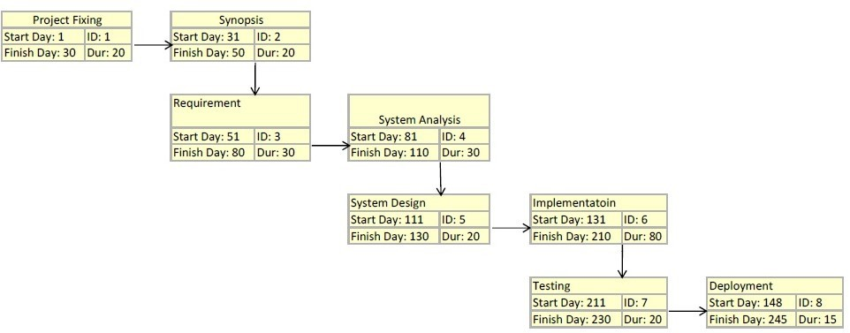

Figure 1: PERT Chart

### 3.5.2 Gantt Chart

The flow of work and time estimation happens in this phase. This contains the task of estimation scheduling and tracking.

In this phase we planned functionality services which component should be used and work flow of our project.

Keeping in mind we estimated the time that will be required for our project.

We planned the schedule required for our project and divided the work between us.

After the project requirements were analyzed, the overall plan for models were built.

Each and every module was considered and designed as per convenience the core function modules were imagined.

 Following table shows the activities and the period in which they are supposed to be performed on:

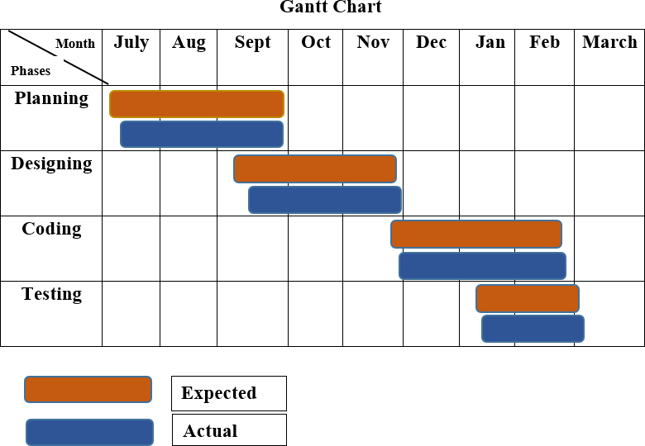

Figure 2: GANTT Chart

## 3.6 Requirement Specification

### 3.6.1 Hardware Requirements

* Hardware: -Intel Core i3 Series 5th Generation Processor
* RAM – 4GB
* ROM -1024GB

### Software Requirements

* Software: -Xampp version 3.2.4
* PhpMyAdmin version 4.9.0.1
* MySQL
* Adobe Photoshop CC 2015

## 3.7 Preliminary Product Description

**Feasibility**

Before the development of Save yOURself, we did a feasibility study by addressing the following feasibility critical issues:

* **Background and need for the project:**

We understood the background and the needs of the project from before starting the development. This included several face-to-face meetings at the early lifecycle of our project.

* **Goals and requirements:**

We understood and jotted down the goals and requirements. We had discussion on every requirement and project goal. Through these discussions, we could eliminate the requirements that were not feasible with the available resources. The goals and requirements which were possible, were converted into milestones. These milestones helped us later to evaluate the final acceptance criteria.

* **Preliminary concept:**

The preliminary concept was compared with the existing systems with the purpose of understanding which requirements are possible and which are not possible. Such comparisons helped us in understanding the system better.

* **Benefits and profitability of the project:**

The project was beneficial and profitable for the developing team as well as the clients because of fewer people working on project which meant lesser resource utilization for the project.

* **Project phases and schedule:**

To make the project feasible, the different phases and schedule of the project was precisely defined in advance.

* **Implementation tools:**

The tools that were used for the development were either free of cost or at a lesser price. This eased up the budget cost of the project.

## 3.8 Conceptual Models

**Spiral Model - Design**

The spiral model has four phases. A software project repeatedly passes through these phases in iterations called Spirals.

**Identification:-**

This phase starts with gathering the business requirements in the baseline spiral. In the subsequent spirals as the product matures, identification of system requirements, subsystem requirements and unit requirements are all done in this phase.

This phase also includes understanding the system requirements by continuous communication between the customer and the system analyst. At the end of the spiral, the product is deployed in the identified market.

**Design:-**

The design phase consists of evaluating whole design of the system by moving through each phase of the proposed system drawing diagrams, data models, etc.

**Construct or Build:-**

The Construct phase refers to production of the actual software product at every spiral. In the baseline spiral, when the product is just thought of and the design is being developed a POC (Proof of Concept) is developed in this phase to get customer feedback.

Then in the subsequent spirals with higher clarity on requirements and design details a working model of the software called build is produced with a version number. These builds are sent to the customer for feedback.

**Evaluation and Risk Analysis:-**

Risk Analysis includes identifying, estimating and monitoring the technical feasibility and management risks, such as schedule slippage and cost overrun. After testing the build, at the end of first iteration, the customer evaluates the software and provides feedback.

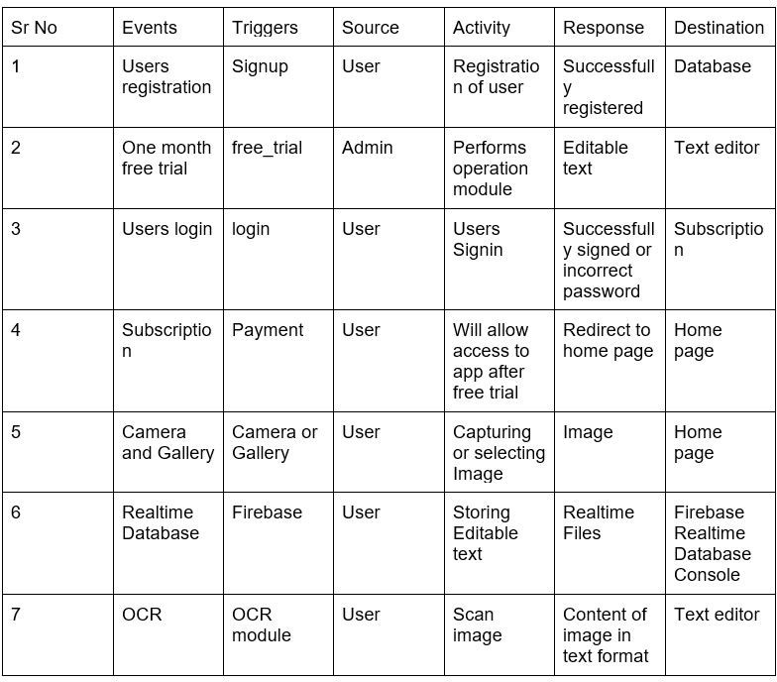

Figure 3: Event Table

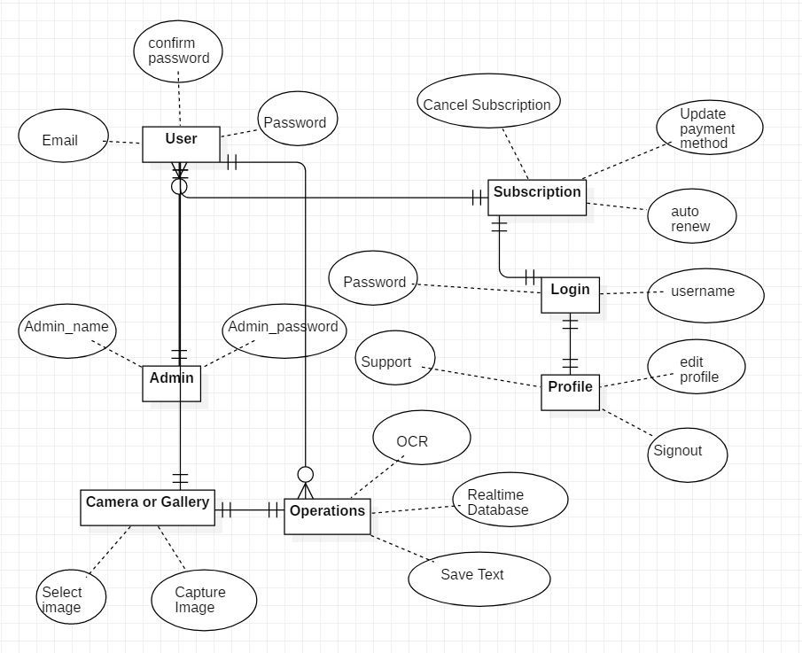

Figure 4: Entity-Relationship Diagram

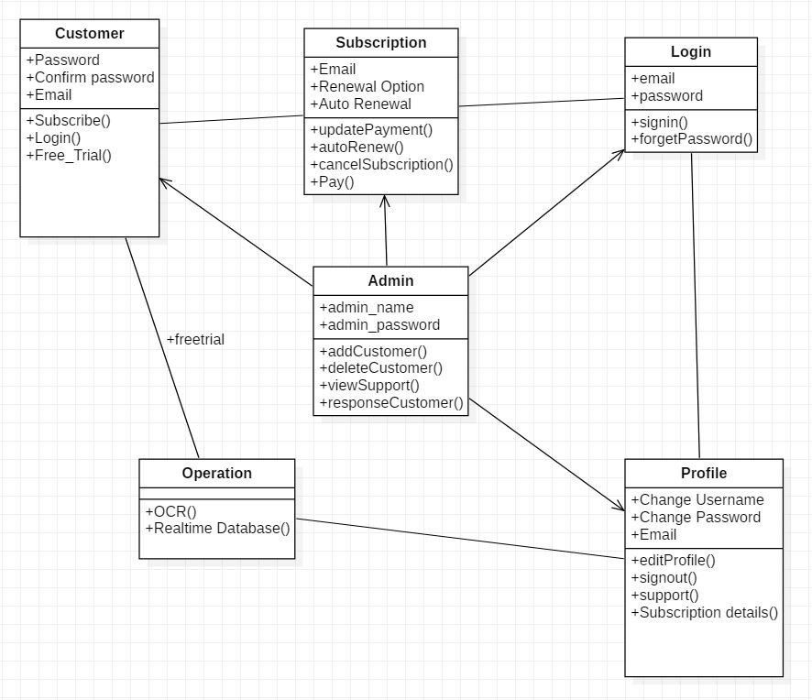

Figure 5: Class Diagram

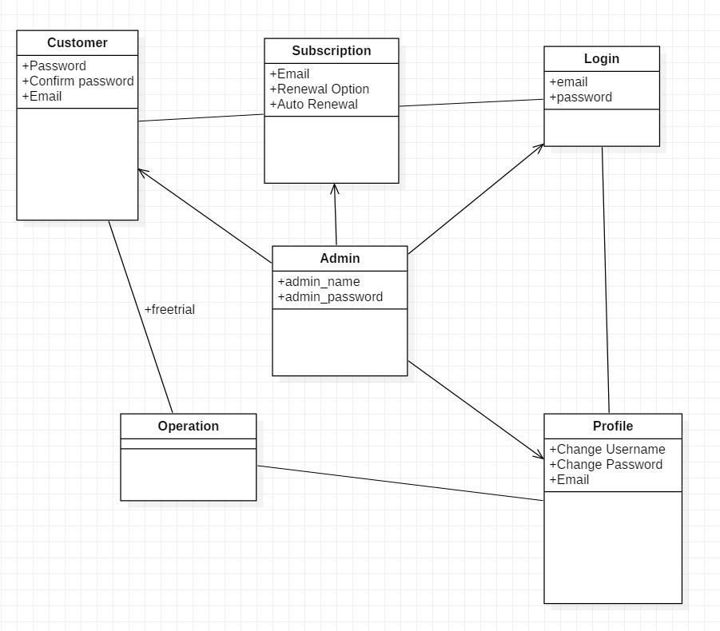

Figure 6: Object Diagram

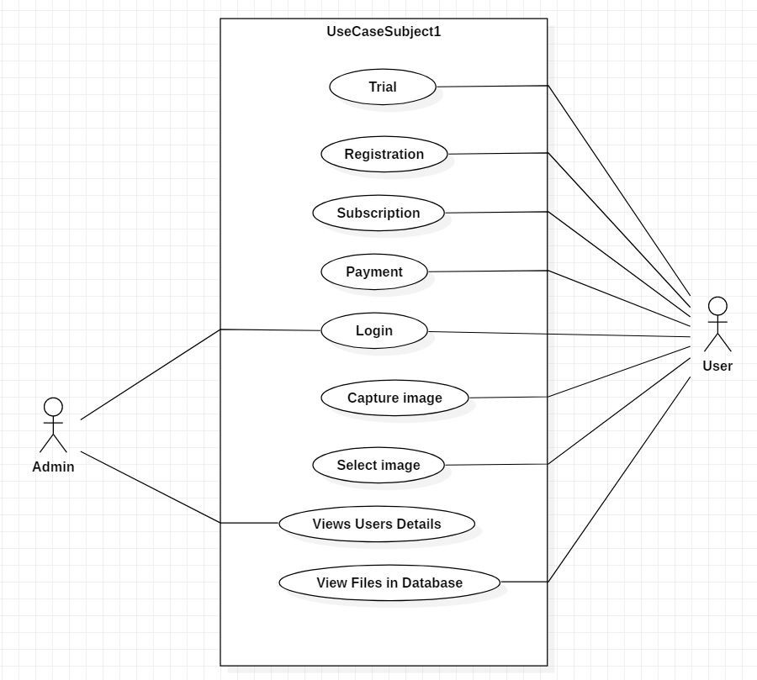

Figure 7: Use Case Diagram

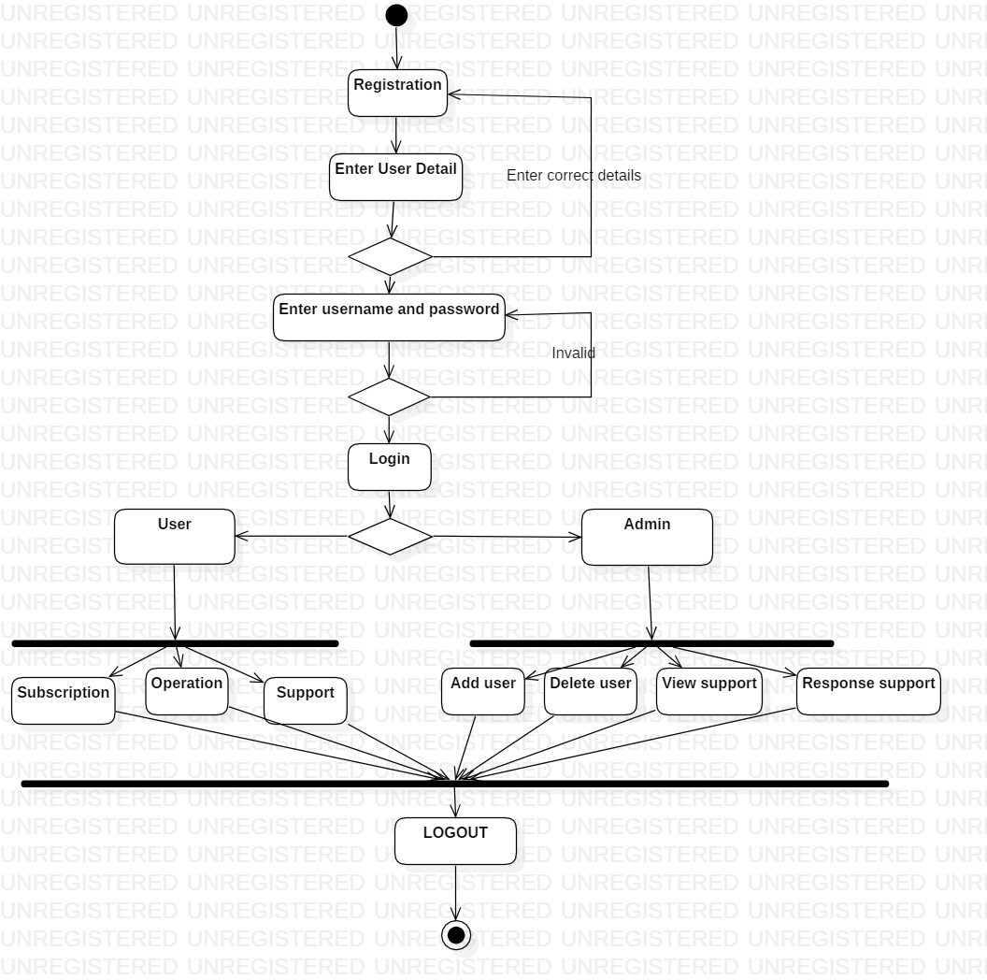

Figure 8: Activity Diagram

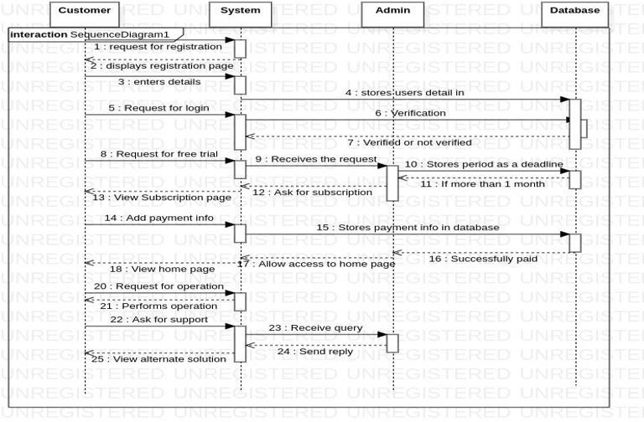

Figure 9: Sequence Diagram

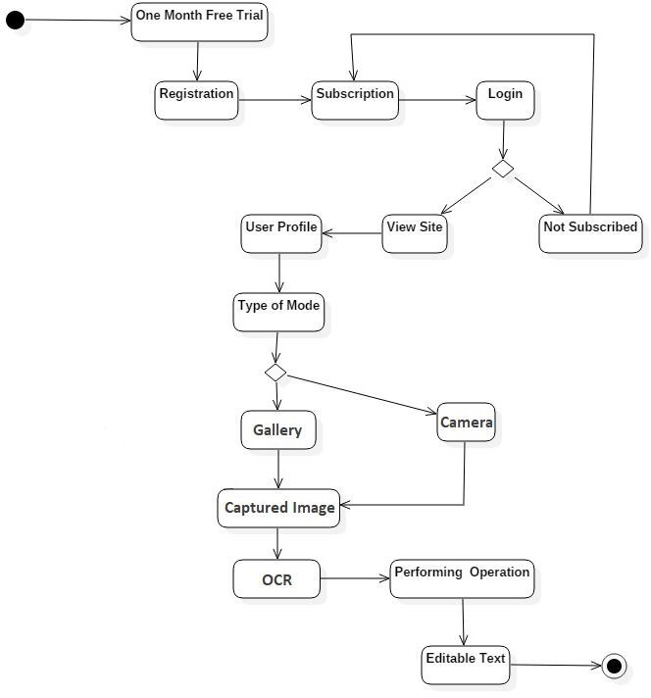

Figure 10: State Diagram

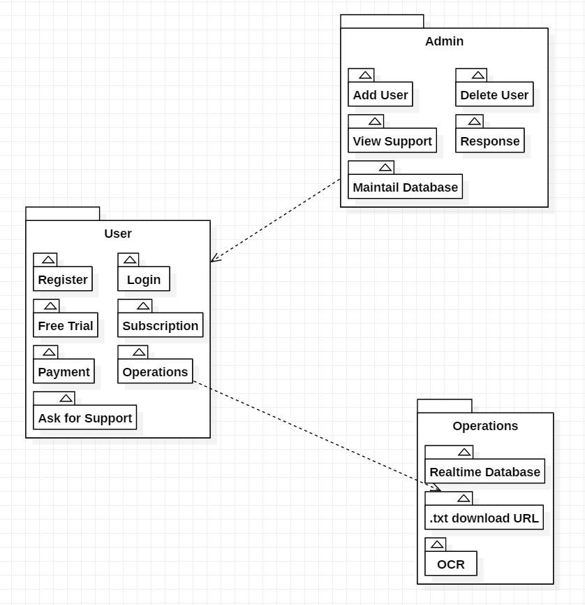

Figure 11: Package Diagram

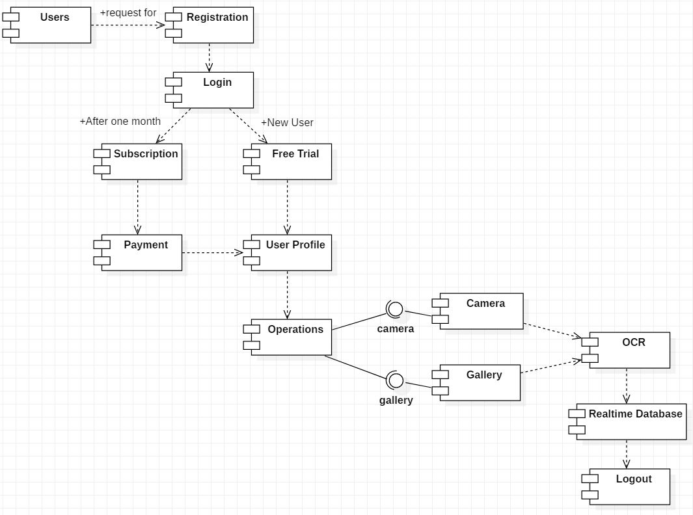

Figure 12: Component Diagram

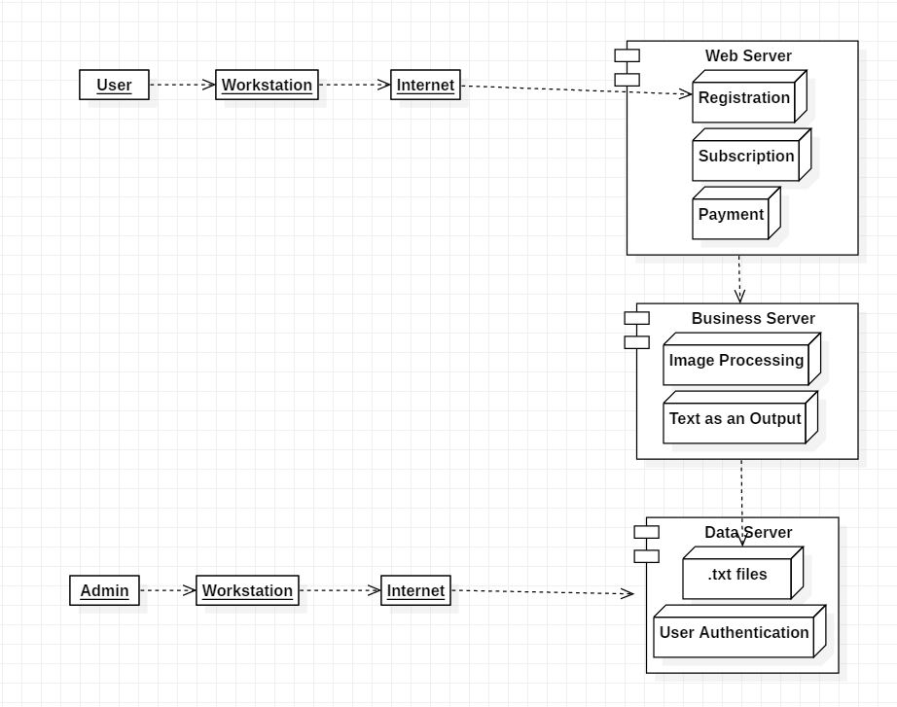

Figure 13: Deployment Diagram

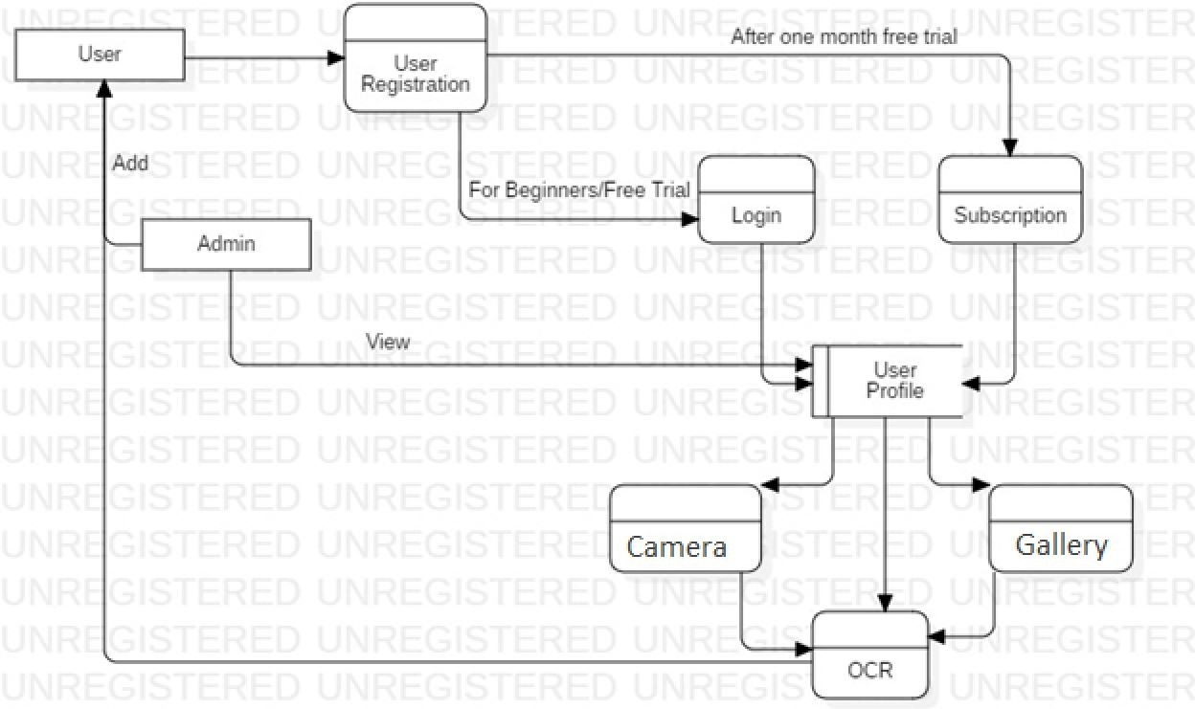

Figure 14: Data Flow Diagram Level

# CHAPTER 4

## 4.1 Basic Modules

Module design is a design approach that subdivides a system into smaller parts called modules or skids that can be independently created and then used in different system. Our project modules are listed below:

* Login and Registration: Every Users has to register with all the details listed on it, and after Registration, you have to login to your account using User-name and password, and if somehow user doesn’t remember his/her password there is an option of forget password,user just need to remember his/her email ID and it will redirect to a page where User can change his password and then login to get into main page where the actual operations will be done.
* Home Page: As the user logs in he/she will be redirected to homepage where the detailed information about the organization will be displayed in about us section and the choose us section will provide information about the features of the company they can view all the complete company details.
* Donation page: On the donation page the user will able to see multiple options through which he/she can donate and the different donate boxes on the bottom of the home page will be redirected on their particular pages.
* Our Work page: In this page the types of work which is done is listed in detailed manner.
* Contact Us page: This page displays the information about the company. Their contact detail. So that the user can easily contact with the organization. To get the idea to user about different tours and what they are applying for.
* MySQL Database: Editable Text in .txt format can be stored in MySQL database so that the User has the accessibility to access the account whenever he wants.

## 4.2 Data Design

**4.2.1 Schema Design**

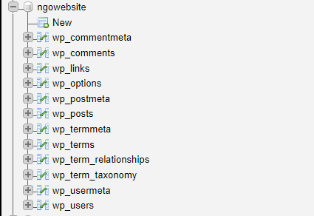

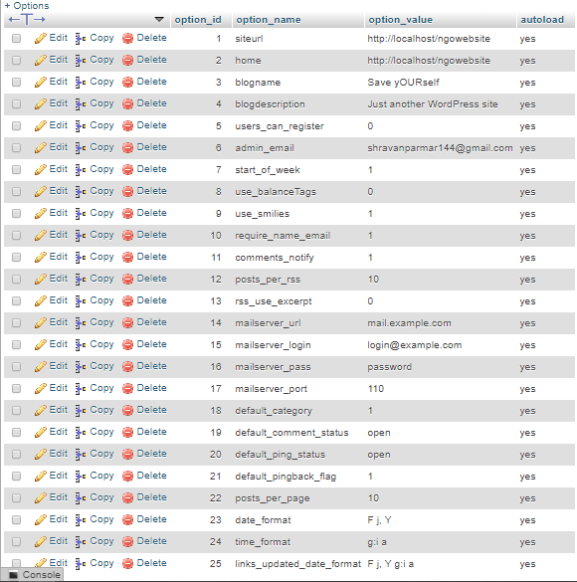

Figure 16: Database Design

**4.2.2 Data Integrity and Constraints**

* Not Null Constraint
* This constraint is set if you don’t want Users to leave any registration attribute as blank, If they do they will get an error.
* Check Constraint
* It is required to check whether the phone number contain 10 digits and G-mail contains (@ and .) symbol in it or not.
* Uniqueness Constraint
* It is Required Because, the Email Id of every user is Unique and if the user try to Sign-up again with the same Id it should show ”User already exist”.

## 4.3 User Interface Design

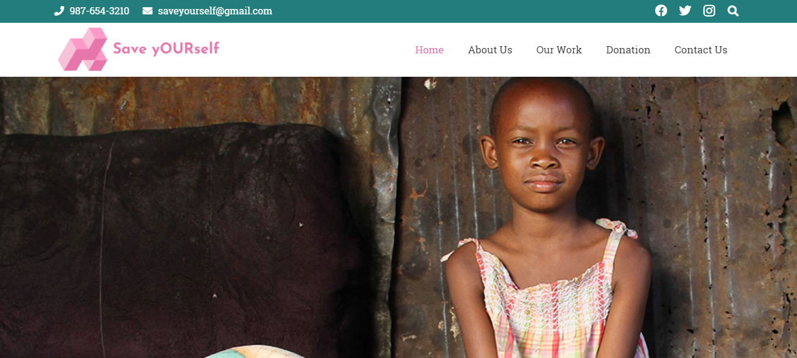

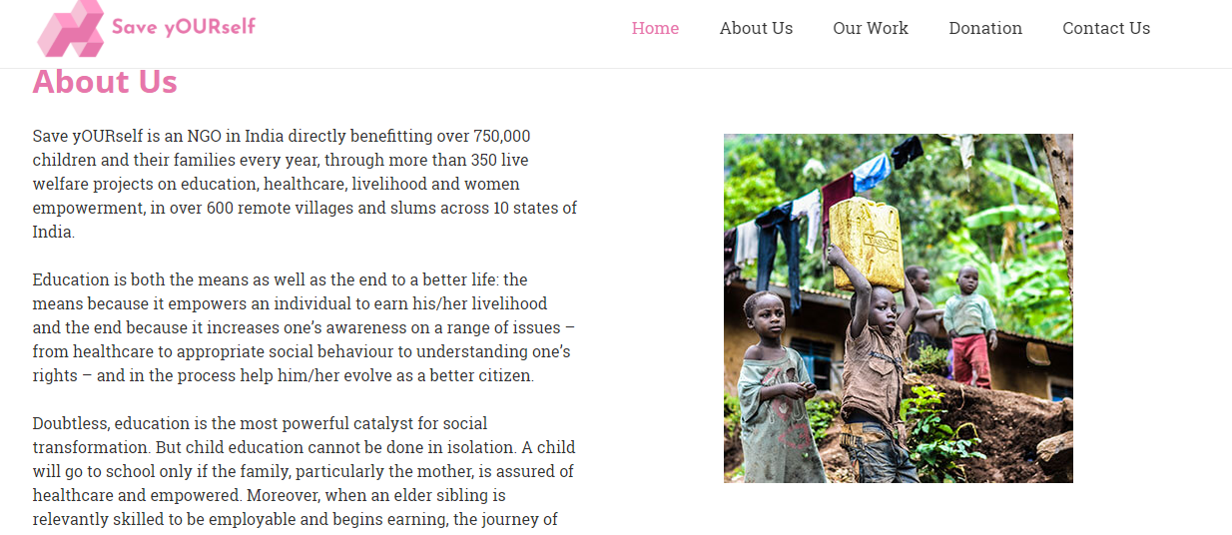

Figure 18: Homepage

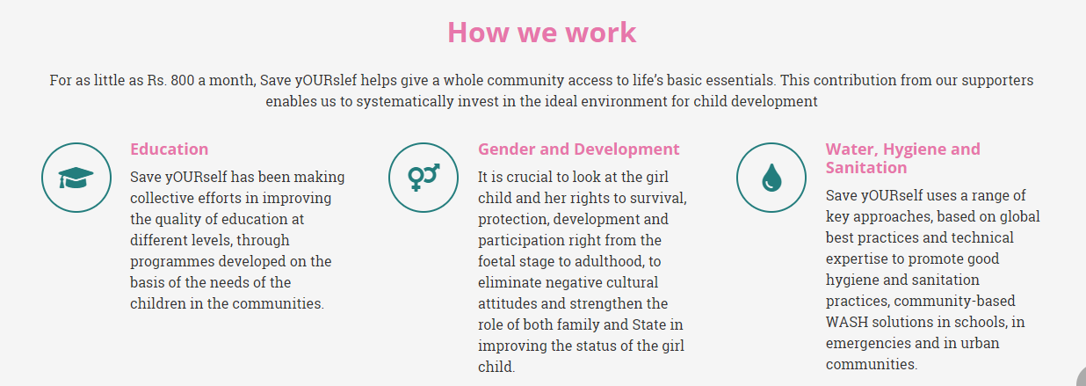

Figure 19: How We Work Section

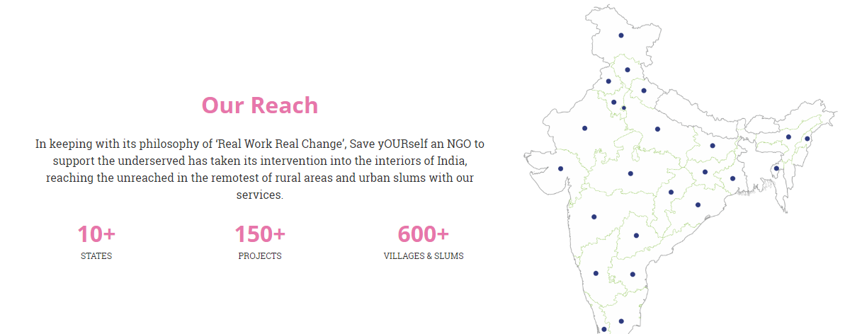

Figure 20: Our Reach Section

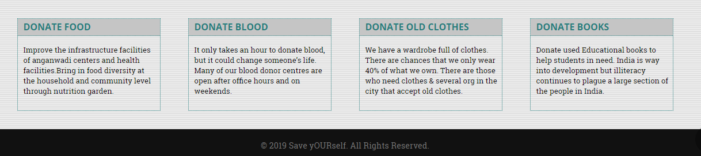

Figure 21: Donation Box Section

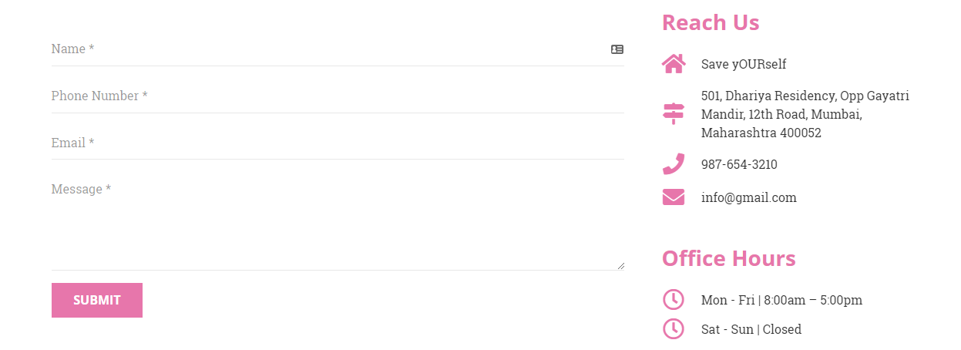

Figure 22: Contact Us Page

## 4.4 Security Issues

* **Data Encryption**
* We are using MySQL to encrypt Users Data. We can Use the concept of Change Password to maintain the Security. Keep updating or Changing the password will also leads to High Security of Information or Data.
* **Authorization**
* Admin Has Authorized to give Permission to Register Users.
* **Authentication**
* We are doing this Approach Because Every User has to authenticate Himself/Herself to Operate our System. Every User will have Unique Gmail Account.
* **Manage Users**
* Only Admin has Rights to Manage Users like, Add Users, Update Users, Remove Users, Grant/revoke the Privileges, etc.

## 4.5 Test Cases Design

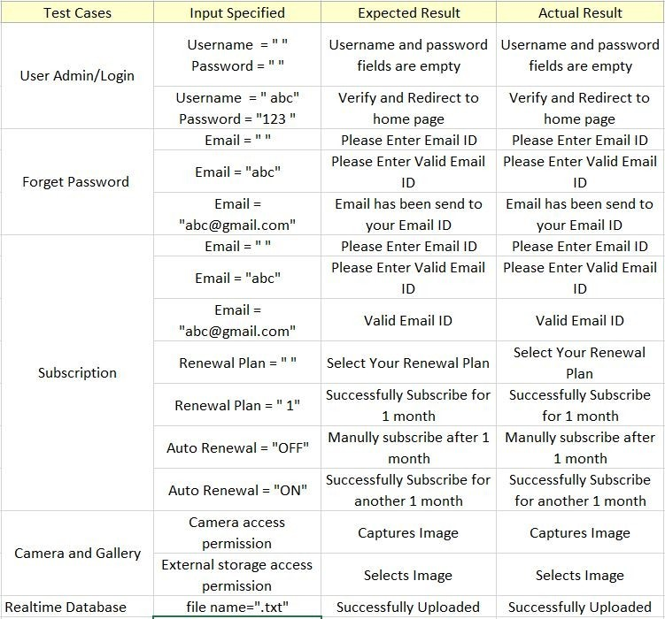

Figure 23: Test Case Design

# CHAPTER 5

# IMPLEMENTATION AND TESTING

## 5.1 Implementation and Approaches

* **Introduction**
* Save yOURself is coming together of various suppliers of services to offer people a complete tourist experience Save yOURself play a vital role in donation. In today’s world Non Profitable Organization are very essential as they provide the necessary help to the people in need. If you are planning to be a part of this organization then you are required to contribute your time and efforts towards the goodwill of the society.
* Save yOURself is a association which works for the betterment and uplifement of socio-economically and politically weaker section of community to bring them in the main stream of society and move the society towards more improved and developed way of living and existence. As a community group and organization Save yOURself provides and fulfills certain services, development oriented tasks and works with aims and objectives to bring about required positive changes in society, community, areas and situations.
* **Input and Output Design Implementation**
* Before starting the Implementation phase, I had to plan about the lay- outs to be use for each module and design them in HTML file accordingly.
* **Code Module**
* This Activity shows the Technologies to be used for my Font-End and Back-End. So, I am Using HTML for designing purpose and javaScript for giving logic to HTML as a Front-End and MySQL as a Back-End. And I am using MySQL Storage for storing the uploads, plugins and theme the text file is Stored in Realtime database which will be reflect in my website. So, Initially the User will have to Register and then Login. So, if the user is valid then the user will be redirected to home page. The Homepage which shows the details and features about the organization and donation packs of the different. On click of pack the page will redirect to the particular donation page and all the details of the package will be shown.
* **System Implementation**
* This activity shows all the main functionality of the project.





Figure 24: Homepage

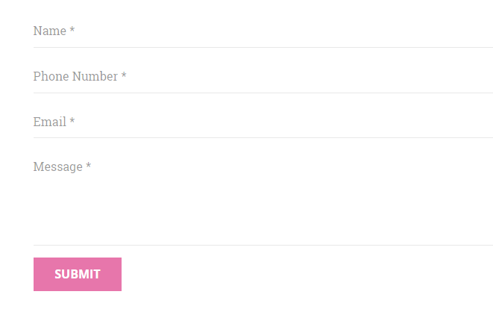

Figure 25: Donation Form

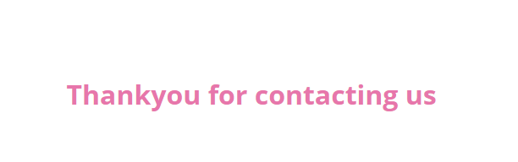

Figure 26: Welcome Page

* **Project Summary**
* So, Initially the User will have to Register and then Login. So, if the user is valid then the user will be redirected to home page. The Homepage which shows the details and features about the organization and donation packs of the different. On click of pack the page will redirect to the particular donation page and all the details of the package will be shown.

## 5.2 Coding Details and Coding Efficiency

* **Home Page**

[vc_row height="auto" width="full"][vc_column][us_image image="155" size="full" align="center"][/vc_column][/vc_row][vc_row height="small" content_placement="middle"][vc_column width="1/2"][vc_column_text]

<h2>About Us</h2>

Save yOURself is an NGO in India directly benefitting over 750,000 children and their families every year, through more than 350 live welfare projects on education, healthcare, livelihood and women empowerment, in over 600 remote villages and slums across 10 states of India.

Education is both the means as well as the end to a better life: the means because it empowers an individual to earn his/her livelihood and the end because it increases one's awareness on a range of issues – from healthcare to appropriate social behaviour to understanding one's rights – and in the process help him/her evolve as a better citizen.

Doubtless, education is the most powerful catalyst for social transformation. But child education cannot be done in isolation. A child will go to school only if the family, particularly the mother, is assured of healthcare and empowered. Moreover, when an elder sibling is relevantly skilled to be employable and begins earning, the journey of empowerment continues beyond the present generation.[/vc_column_text][/vc_column][vc_column width="1/2"][us_image image="195" size="full" align="center"][/vc_column][/vc_row][vc_row us_bg_overlay_color="#f5f5f5"][vc_column][vc_column_text]

<h2 class="hw-head">How we work</h2>

<p class="hw-para">For as little as Rs. 800 a month, Save yOURslef helps give a whole community access to life's basic essentials. This contribution from our supporters enables us to systematically invest in the ideal environment for child development</p>

[/vc_column_text][/vc_column][vc_column][vc_row_inner][vc_column_inner width="1/3"][us_iconbox icon="fas|graduation-cap" color="secondary" style="outlined" size="32px" iconpos="left" title="Education" title_size="18px" title_tag="h5" link="url:http%3A%2F%2Flocalhost%2Fngowebsite%2Feducation%2F|||" alignment="left"]Save yOURself has been making collective efforts in improving the quality of education at different levels, through programmes developed on the basis of the needs of the children in the communities.[/us_iconbox][/vc_column_inner][vc_column_inner width="1/3"][us_iconbox icon="fas|venus-mars" color="secondary" style="outlined" size="32px" iconpos="left" title="Gender and Development" title_size="18px" title_tag="h5" link="url:http%3A%2F%2Flocalhost%2Fngowebsite%2Fgender-equality%2F|||" alignment="left"]It is crucial to look at the girl child and her rights to survival, protection, development and participation right from the foetal stage to adulthood, to eliminate negative cultural attitudes and strengthen the role of both family and State in improving the status of the girl child.[/us_iconbox][/vc_column_inner][vc_column_inner width="1/3"][us_iconbox icon="fas|tint" color="secondary" style="outlined" size="32px" iconpos="left" title="Water, Hygiene and Sanitation" title_size="18px" title_tag="h5" link="url:http%3A%2F%2Flocalhost%2Fngowebsite%2Fsanitation%2F|||" alignment="left"]Save yOURself uses a range of key approaches, based on global best practices and technical expertise to promote good hygiene and sanitation practices, community-based WASH solutions in schools, in emergencies and in urban communities.[/us_iconbox][/vc_column_inner][/vc_row_inner][us_separator size="small"][vc_row_inner][vc_column_inner width="1/3"][us_iconbox icon="fas|rupee-sign" color="secondary" style="outlined" size="32px" iconpos="left" title="Livelihood" title_size="18px" title_tag="h5" link="url:http%3A%2F%2Flocalhost%2Fngowebsite%2Flivelihood%2F|||" alignment="left"]To ensure a successful livelihood programme, the community members identify the business activity that is suitable for them in the local context and can be sustained. The community members are also trained by technical experts on the best way to promote the business.[/us_iconbox][/vc_column_inner][vc_column_inner width="1/3"][us_iconbox icon="fas|utensils" color="secondary" style="outlined" size="32px" iconpos="left" title="Nutrition" title_size="18px" title_tag="h5" link="url:http%3A%2F%2Flocalhost%2Fngowebsite%2Fnutrition%2F|||" alignment="left"]The most damaging effects of under-nutrition occur during pregnancy and the first two years of a child’s life. These damages are irreversible; hence dealing with malnutrition in the first two years is crucially important.[/us_iconbox][/vc_column_inner][vc_column_inner width="1/3"][us_iconbox icon="fas|wheelchair" color="secondary" style="outlined" size="32px" iconpos="left" title="Disability" title_size="18px" title_tag="h5" link="url:http%3A%2F%2Flocalhost%2Fngowebsite%2Fdisability%2F|||" alignment="left"]The objective of our work around disability is that people and children with disabilities will have equal opportunities to enjoy dignity, self worth and self reliance without any discrimination, barriers and bias.[/us_iconbox][/vc_column_inner][/vc_row_inner][/vc_column][/vc_row][vc_row height="small" content_placement="middle"][vc_column width="7/12"][vc_column_text]

<h2 class="or-h">Our Reach</h2>

<p class="or-p">In keeping with its philosophy of ‘Real Work Real Change’, Save yOURself an NGO to support the underserved has taken its intervention into the interiors of India, reaching the unreached in the remotest of rural areas and urban slums with our services.</p>

[/vc_column_text][vc_row_inner][vc_column_inner width="1/3"][vc_column_text]

<h2 class="rb-head">10+</h2>

<p class="rb-para">STATES</p>

[/vc_column_text][/vc_column_inner][vc_column_inner width="1/3"][vc_column_text]

<h2 class="rb-head">150+</h2>

<p class="rb-para">PROJECTS</p>

[/vc_column_text][/vc_column_inner][vc_column_inner width="1/3"][vc_column_text]

<h2 class="rb-head">600+</h2>

<p class="rb-para">VILLAGES &amp; SLUMS</p>

[/vc_column_text][/vc_column_inner][/vc_row_inner][/vc_column][vc_column width="5/12"][us_image image="44" size="full" align="center"][/vc_column][/vc_row][vc_row height="small" color_scheme="custom" us_bg_color="#f5f5f5" us_text_color="#0a0a0a" us_bg_image_source="media" us_bg_image="114" us_bg_size="initial" us_bg_pos="top left" el_class="e-footer"][vc_column width="1/4"][vc_column_text el_class="free"]

<h2>Donate Food</h2>

Improve the infrastructure facilities of anganwadi centers and health facilities.Bring in food diversity at the household and community level through nutrition garden.[/vc_column_text][/vc_column][vc_column width="1/4"][vc_column_text el_class="free"]

<h2>Donate Blood</h2>

It only takes an hour to donate blood, but it could change someone's life.

Many of our blood donor centres are open after office hours and on weekends.[/vc_column_text][/vc_column][vc_column width="1/4"][vc_column_text el_class="free"]

<h2>Donate Old Clothes</h2>

We have a wardrobe full of clothes. There are chances that we only wear 40% of what we own. There are those who need clothes &amp; several org in the city that accept old clothes.[/vc_column_text][/vc_column][vc_column width="1/4"][vc_column_text el_class="free"]

<h2>Donate Books</h2>

Donate used Educational books to help students in need. India is way into development but illiteracy continues to plague a large section of the people in India.[/vc_column_text][/vc_column][/vc_row]

* **AboutUs Page**

<h2> Our Mission</h2>

Save yOURself is to empower underprivileged children, youth and women through relevant education, innovative healthcare and market-focused livelihood programmes.

Save yOURself is to deploy best possible methodology and technology for achieving ideal SROI (social return on investment), to practice and promote good governance. To link business competitiveness of the corporate with social development initiatives; also to sensitize privileged children, youth and citizens in general to promote Civic Driven Change.

<img src="http://localhost/ngowebsite/wp-content/uploads/2019/09/example-300x300.jpg" alt="" width="300" height="250" class="alignright size-medium wp-image-156" /><h2>Belief</h2>

Save yOURself believes that unless members of the civil society are involved proactively in the process of development, sustainable change will not happen. Believing in this principle of 'Civic Driven Change',Save yOURself sensitises the civil society in order to make them partners in its mission.

<h2>Approach</h2>

Save yOURself believes that education is both the means as well as the end to a better life: the means because it empowers an individual to earn his/her livelihood and the end because it increases one's awareness on a range of issues - from healthcare to appropriate social behaviour to understanding one's rights - and in the process help him/her evolve as a better citizen. Education is the most effective tool which helps children build a strong foundation; enabling them to free themselves from the vicious cycle of ignorance, poverty and disease.

Save yOURself realised that Education for Children cannot be achieved without the family, particularly, unless the mother is assured of health care and empowered. Moreover, when an elder sibling is educated and relevantly skilled to be employable and begins earning, the journey of empowerment continues beyond the present generation.

Save yOURself extended its thematic areas of intervention by supporting family health, livelihood, and women empowerment. Children, their families and the community become the target group for Smile Foundation's activities as child education cannot be done in isolation and nothing else but education for children can bring long lasting change in the society.

* **OurWork Page**

Save yOURself also partners people’s organisations at grassroot levels to advocate with government to effectively implement the Right to Education act. Save yOURself, in collaboration with the community based organisations, provides financial support to appoint additional teachers and transform school environment, making it conducive for children to learn. In order to sustain the results, Save yOURself facilitates enhancement of the economic status of families, for parents to be able to provide quality education for their children.

<h2>In order to improve the quality of education, Save yOURself follows a multidimensional strategy</h2>

<img src="http://localhost/ngowebsite/wp-content/uploads/2019/09/education-300x300.jpg" alt="" width="300" height="250" class="alignright size-medium wp-image-165" /><ul>

<li>Work closely with government, community-based organisations and other stakeholders in the effective implementation of Right To Education Act.</li>

<li>Develop and pilot appropriate learning models and practices at the grass-root level to enhance the quality of learning.</li>

<li>Partner with government departments/ training institutions to build the capacity of teachers and teaching volunteers.</li>

<li>Empower communities to monitor the functioning of schools and advocate for the implementation of various Acts and Entitlements for quality education for all children.</li>

<li>Provide livelihood programmes for parents to enable them to earn a steady income to support their children’s education.</li>

<li>Support school-going children from vulnerable families by providing study materials, arranging special coaching programs, sharing course fees and encouraging children to enroll in vocational and professional education.</li>

</ul>

* **Donation Page**

<p>[vc_row height="auto" width="full"][vc_column][us_image image="179" size="full" align="center"][/vc_column][/vc_row][vc_row][vc_column][vc_column_text]Save yOURself is a not-for-profit social organization which aims to solve the problem of hunger, malnutrition and food waste in the country. We channelize extra nutritious food from individuals, weddings, restaurants, corporate offices to the people who really need it and have no means or access food. We also serve freshly cooked food or raw grains to our partnered shelter homes and beneficiaries.</p>

<h2>Steps involved to feed the needy</h2>

<ul>

<li>Food Donor makes a food donation request on the Save yOURself helpline number.</li>

<li>Save yOURself Hunger Heroes / food recovery vans reach donor location.</li>

<li>Hunger Heroes check and collect the food.</li>

<li>Transport and donate the food to hungry with their own hands.</li>

</ul>

<p>[/vc_column_text][/vc_column][/vc_row]</p>

* **ContactUs Page**

<p>[vc_row content_placement="middle"][vc_column width="2/3"][us_cform items="%5B%7B%22type%22%3A%22text%22%2C%22placeholder%22%3A%22Name%22%2C%22required%22%3A%221%22%7D%2C%7B%22type%22%3A%22text%22%2C%22placeholder%22%3A%22Phone%20Number%22%2C%22required%22%3A%221%22%7D%2C%7B%22type%22%3A%22email%22%2C%22placeholder%22%3A%22Email%22%2C%22required%22%3A%221%22%7D%2C%7B%22type%22%3A%22textarea%22%2C%22placeholder%22%3A%22Message%22%2C%22required%22%3A%221%22%7D%5D" button_style="2"][/vc_column][vc_column width="1/3"][us_separator show_line="1" line_width="30" thick="3" color="secondary"][vc_column_text]</p>

<h3>Reach Us</h3>

<p>[/vc_column_text][us_iconbox icon="fas|home" size="28px" iconpos="left" title="Save yOURself" title_size="16px" title_tag="p" link="url:http%3A%2F%2Flocalhost%2Fngowebsite%2F|||" alignment="left"][/us_iconbox][us_separator size="custom" height="15px"][us_iconbox icon="fas|map-signs" size="28px" iconpos="left" title="501, Dhariya Residency, Opp Gayatri Mandir, 12th Road, Mumbai, Maharashtra 400052" title_size="16px" title_tag="p" link="url:https%3A%2F%2Fgoo.gl%2Fmaps%2F4589ewyAJtF2||target:%20_blank|" alignment="left"][/us_iconbox][us_separator size="custom" height="15px"][us_iconbox icon="fas|phone" size="28px" iconpos="left" title="987-654-3210" title_size="16px" title_tag="p" link="url:tel%3A9876543210||target:%20_blank|" alignment="left"][/us_iconbox][us_separator size="custom" height="15px"][us_iconbox icon="fas|envelope" size="28px" iconpos="left" title="info@gmail.com" title_size="16px" title_tag="p" link="url:mailto%3Ainfo%40gmail.com||target:%20_blank|" alignment="left"][/us_iconbox][us_separator][vc_column_text]</p>

<h3>Office Hours</h3>

<p>[/vc_column_text][us_iconbox icon="far|clock" size="28px" iconpos="left" title="Mon - Fri | 8:00am – 5:00pm" title_size="16px" title_tag="p" alignment="left"][/us_iconbox][us_separator size="custom" height="10px"][us_iconbox icon="far|clock" size="28px" iconpos="left" title="Sat - Sun | Closed" title_size="16px" title_tag="p" alignment="left"][/us_iconbox][us_separator show_line="1" line_width="30" thick="3" color="secondary"][/vc_column][/vc_row][vc_row height="auto" width="full"][vc_column][vc_column_text]<iframe style="border: 0;" src="https://www.google.com/maps/embed?pb=!1m14!1m8!1m3!1d15085.605261986222!2d72.8588532!3d19.0460851!3m2!1i1024!2i768!4f13.1!3m3!1m2!1s0x0%3A0x5922d5c3dd0b2201!2sVaibhav%20Building!5e0!3m2!1sen!2sin!4v1569055992124!5m2!1sen!2sin" width="100%" height="450" frameborder="0" allowfullscreen="allowfullscreen"></iframe>[/vc_column_text][/vc_column][/vc_row]</p>

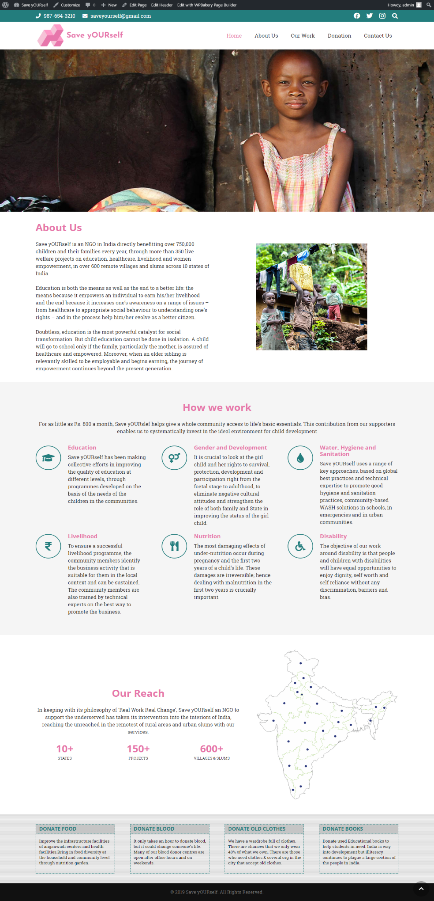

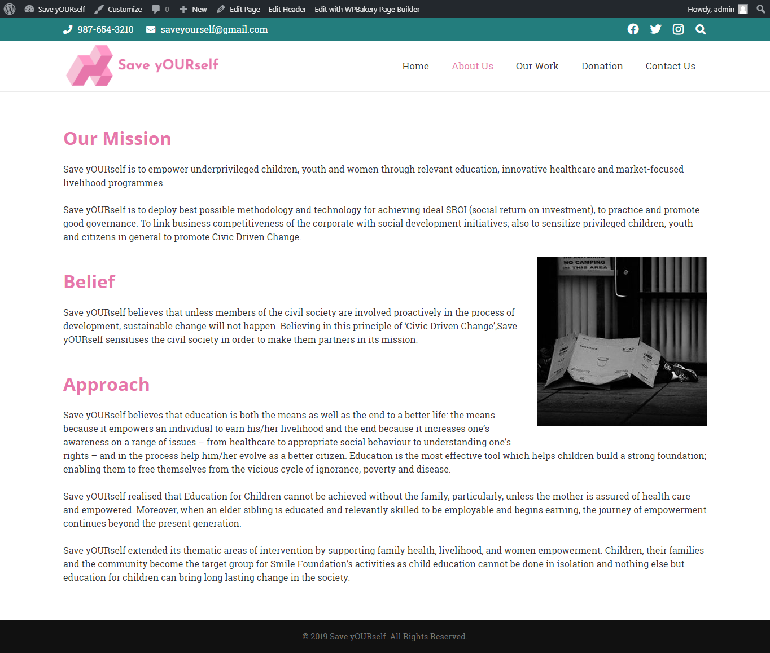

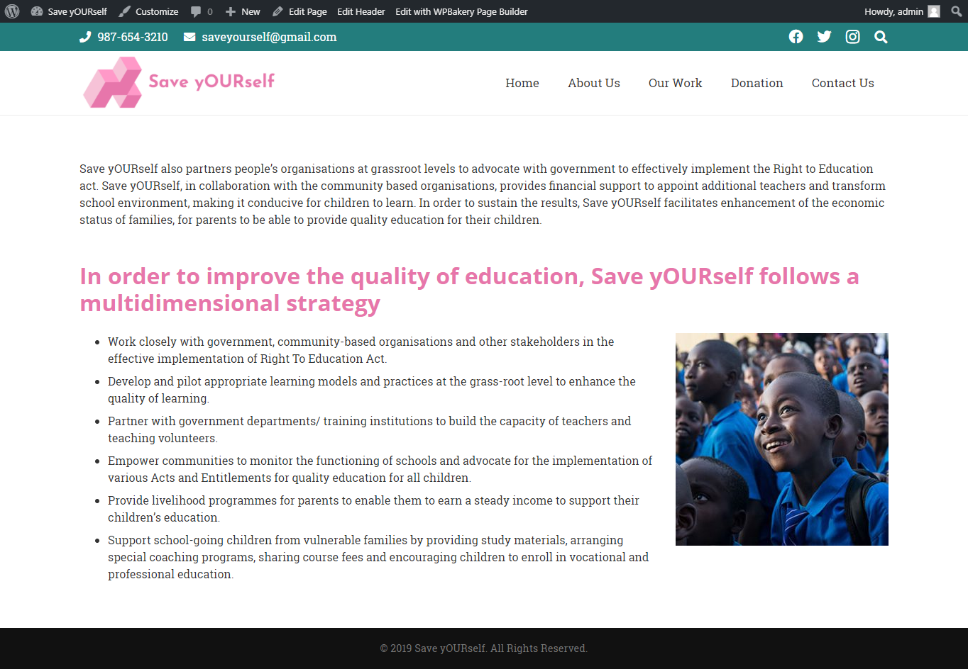

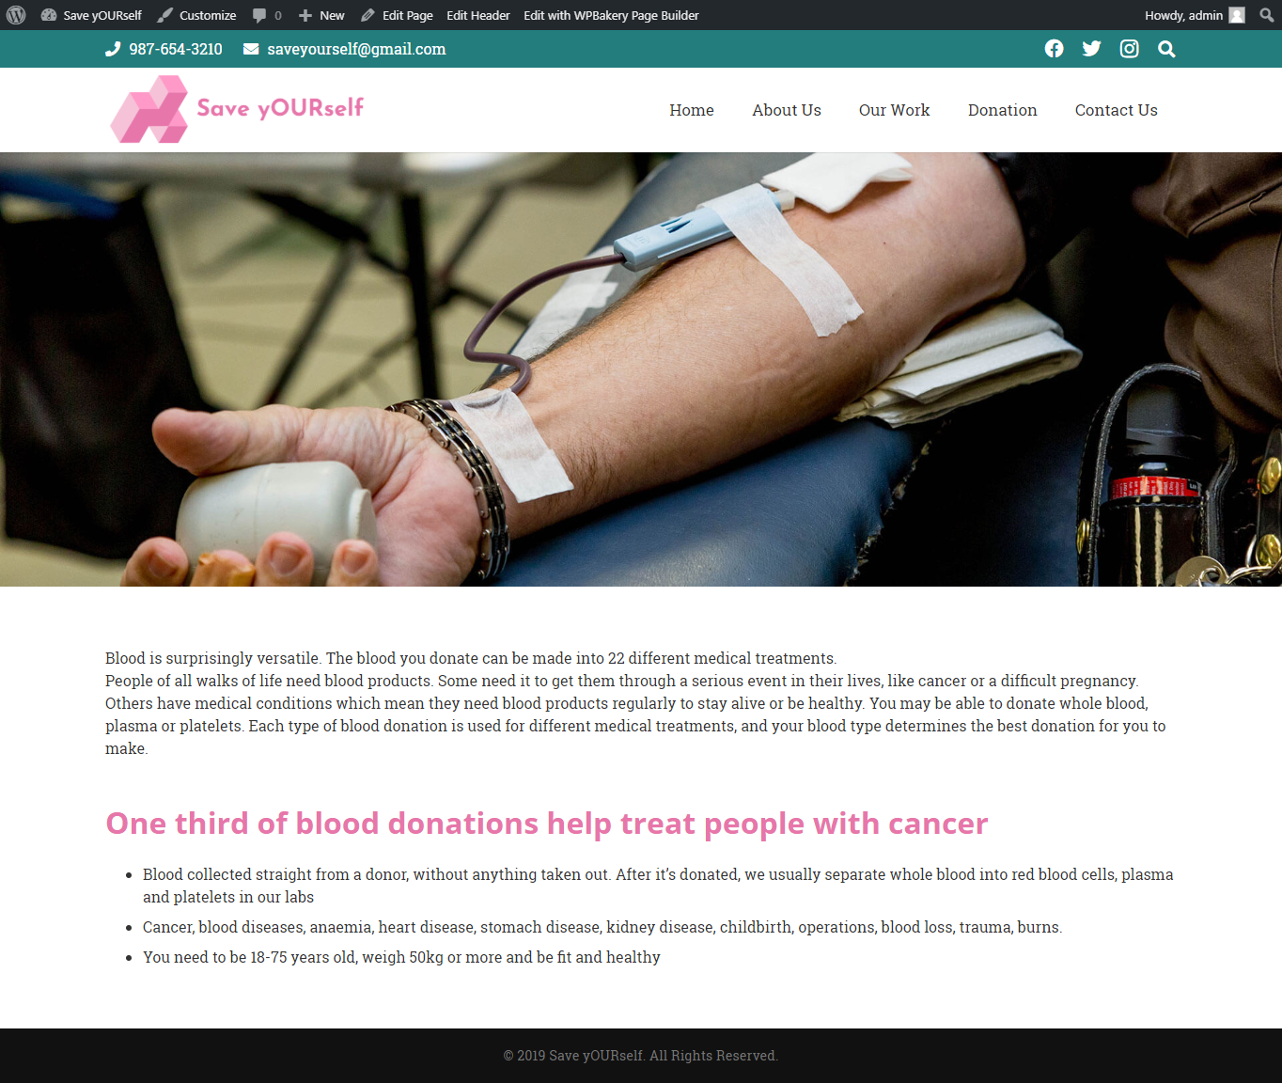

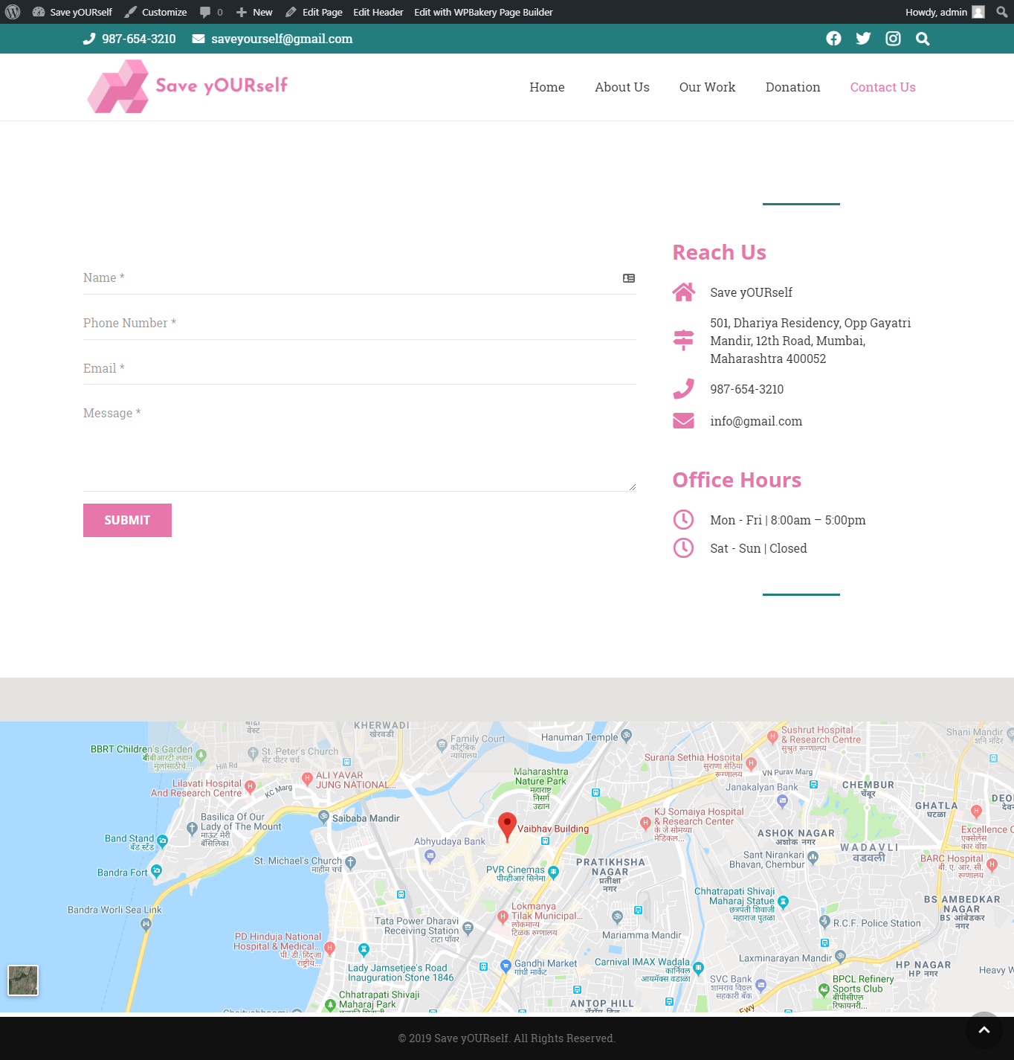

## 

**5.2.1 Code Efficiency**

The above are the coding conventions that were followed while writing the source code of the project:

This style guide is mostly based on the standards that are currently prevalent in JavaScript, although some conventions (i.e async/await or static class fields) may still be included or prohibited on a case-by-case basis.

## 5.3 Testing Approach

## The testing that was performed on our website was different from those that are performed on most IT projects. The website was tested via a concept called “Web Testing”. Web testing is the name given to software testing that focuses on websites. Complete testing of a web-based system before going live can help address issues before the system is revealed to the public. Issues such as the security of the website, the basic functionality of the site, its accessibility to handicapped users and fully able users, as well as readiness for expected traffic and number of users and the ability to survive a massive spike in user traffic, both of which are related to load testing.

## 5.3.1 Functionality Testing:

## Functional testing is a quality assurance (QA) process and a type of black box testing that bases its test cases on the specifications of the software component under test. Under functional testing we checked

## 5.3.2 Database testing

## In database testing, the performance and response time of the database was tested and for queries that took more time for response, a necessary restructure of database was done. Most queries returned response within seconds, despite large number of Documents as shown in screenshot. We used Chrome Extension Postman which help to test our database response.

## 5.3.3 Usability testing

## This testing involves checking how easy it is to use the website. We checked whether main menu was available on all the pages. Use of dark colours annoys the users, and so, we checked if the colours that are used throughout the website are easy on the eyes. This is the main reason why the website uses white colour in most areas and Flat colour for differentiate the buttons and other part of webpage. Fonts that are used on the website are web safe fonts7.

## 5.3.4 Interface testing

## This testing involved checking how well errors were handled and what were the messages that were displayed to the end users.

## 5.3.5 Compatibility testing

## This testing involved checking if the website was loading at least the necessary aspects in the most presentable form on different type of browsers and on different resolutions. It also included checking the responsiveness of the website to mobile of different resolutions. For this we use Chrome Extension Mobile/RWD Tester to test Responsiveness of Web page.

## 5.3.6 Performance testing

## In this testing, we loaded the website on the web server and checked if the website crashed after loading some specific web pages a lot of times. The results were successful since we did this testing on a small scale (due to lack of resources).

# CHAPTER 6

# RESULT AND DISCUSSIONS

## 6.1 Test Reports



Figure 32: Test Report

## 6.2 User Documentation

* So, Initially the User will have to Register and then Login. So, if the user is valid then the user will be redirected to home page. The Homepage which shows the details and features about the organization and donation packs of the different. On click of pack the page will redirect to the particular donation page and all the details of the package will be shown.

# CHAPTER 7

# CONCLUSION

## 7.1 Conclusion

Users can only use my website Online. Website will help the user to gain information about different types of donation across the states. With the help of this website planning of the user becomes easier and it also helps the user to compare from different website which lessens the risk of scam of money donated through online donation system.

## 7.2 Limitation of the System

Internet is the core of this project and without internet there won’t be any access to the features of the project. This website is only available for our country, It does not cover other remote places across the country. The website cannot be accessed when the user is offline.

## 7.3 Future Scope of the Project

In order to solve the major issues, that’s going across the world, we have come up with this project which will solve a problem. This website can be used in the future for donation purpose for different destination across the globe. To spread awareness around the globe.

# REFERENCE

* [www.wikipedia.com](http://www.wikipedia.com/)
* [www.w3schools.com](http://www.w3schools.com/)
* www.smilefoundationindia.org
* [www.donateblood.com.](http://www.donateblood.com.)
* [https://udayfoundation.org](https://www.udayfoundation.org/)
* <https://www.worldvision.in/>